Table of Contents
Genre 1
System Requirements 1
Game Mechanics 1
Game Story 2
Game Controls & User Interface 3
Monetization 3
Replayability 4
Sequel 4
Inspirations & Examples 4
Asset List 4

Genre
Reignite is a hybrid Adventure (Exploration) and Rhythm game.

System Requirements
PC / Mac. Mouse and Keyboard. Perhaps expand with Controller support for consoles.

Game Mechanics
For the Adventure / Exploration sections of the game, the mechanics are simple and finite. As such, the required mechanics are movement, eight way, in three dimensions. Additionally, interactivity with objects, including things like doors, notebooks, chalkboards, and other objects.

For the Rhythm sections of the game, more detailed mechanics are required. These are the sections of the game which are truly interactive, where conflict and a goal is established. They will be controlled using a hybrid mouse and keyboard control scheme, where vertical mouse movement controls the current pitch and a keyboard button press (or multiple) follows the rhythm of a playing song.
Because of this hybrid control scheme, a multifaceted scoring system based on both Mouse and Keyboard accuracy will be required. Also, visual rewards (animations / graphics) will be provided during play as a reward for doing well.
Perhaps the most important aspect of the rhythm section is creating a scrolling note chart, which will need to be synchronized with the playing music. As such, all song files will be created in both a standard format and as a midi file, which will be parsed and used to generate a note chart.

Game Story
Premise:
Reignite is the story of The Violinist [default name TBD], a young girl who finds herself in a dark and dream-like version of her high school. The buildings have no electricity. The night outside is seemingly eternal. The only source of light she has is a candle, which ignites as she plays music on her violin.
Fragments of story are found as she progresses, through memories, notes, and fellow musicians she encounters and saves through music. One by one, she ignites candles for her friends, bringing light to this shadowed world. With their instruments and musical skills as their weapons, The Violinist and her friends search for answers about the origin of this world and how they can break free from the darkness.
Story is subject to change.

Game Controls & User Interface
Controls:
For the exploration sections, control of the player using the WASD keys for movement, with an interact button on objects that will provide story / background.

For the rhythm game sections, vertical mouse control and keyboard keys QWER. The mouse movement matches a pitch, while a keyboard key is pressed. This leads to two forms of accuracy, “Pitch” accuracy for the mouse input, and “Rhythm” accuracy for the button presses.
User Interface:
For the exploration sections, HUD/GUI will be limited or non-existent. Objects that can be interacted with will have an outline / glow when the player is near them indicating that they can be interacted with.

For the rhythm game sections, the UI is still being determined, but it will be the container for the gameplay, the note chart. The note chart will have an indicated area (highlighted near the left side of the screen) for the current beat, which will be where the cursor is locked. The cursor will be indicated by a flame, which will grow and light up as the player does well, and dims when they miss notes.

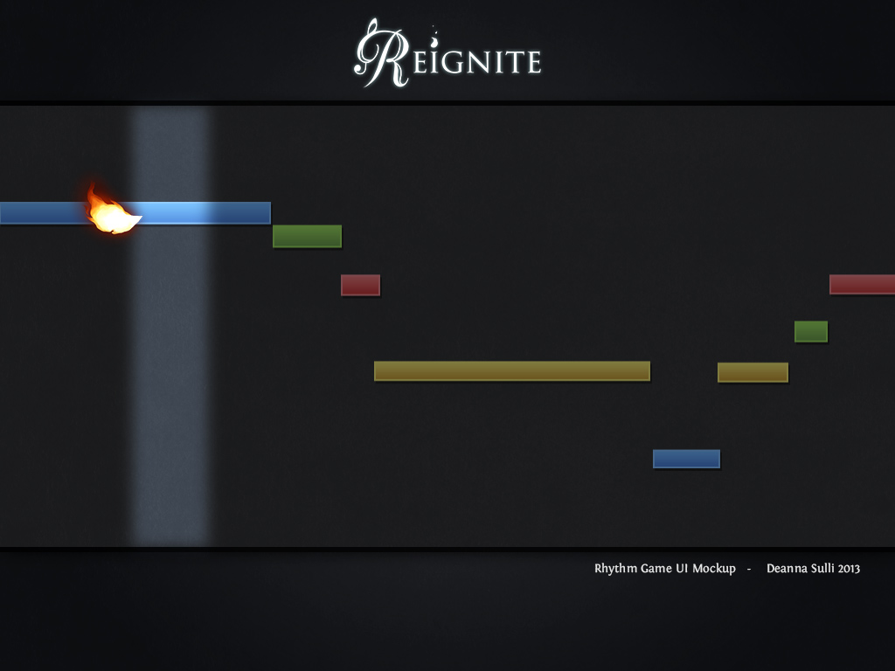
The user will be taught that a color is tied to exclusively a single key. For example, blue is “Q”, green is “W”, red is “E”, and yellow is “R.” This color scheme will remain consistent throughout the game so that the UI remains minimal without unnecessary text.

Monetization
Depending on the style of release we target, the game will either be a pay-for-play at a price point around $10 or $15, or a chapter-based game where the first chapter, the Prelude, will be released for free. Subsequent chapters will be released as $3-$5 transactions.

Replayability
The unique art style, music, exploration and story aspects, and a variable difficulty.

Sequel
The game we seek to make is the Prelude, merely Chapter One, in a longer story. These can either be in sequel, DLC, or same-game format, but the game we seek to make is just the beginning of the Reignite project, which will consist of many chapters.

Inspirations & Examples
For exploration, Shin Megami Tensei: Persona 4 (graphical / environment), Amnesia: The Dark Descent (atmosphere / style of storytelling).
For art, Legend of Zelda: Wind Waker HD, Spire by Hitbox Team.
For the rhythm game elements, Rock Band’s singing mechanic (pitch matching), Final Fantasy: Theatrhythm, Project Diva / Technica.

Asset List
For the Prelude, 4 (FOUR) characters are required.
1. Violin 1 – PROTAGONIST
(Current character design)
2. Violin 2 – Adella
(Currently being redesigned)
3. Viola – Oliver
(Old, temporary artwork to be replaced)
4. Cello – Arthur

Antagonist:

Several animations are required for the PROTAGONIST, such as a walking and/or running animation, as well as one for playing her instrument.
A minimum of 6 (SIX) songs or song clips are required - 4 (FOUR) of these will be public domain songs for solo violin or string quartet, recreated. The remaining 2 (TWO) songs will be atmospheric during the exploration segments.

Sound Effects for certain things may also be required, for example, a crackling flame, a variety of footstep sounds, and the sounds of doors.
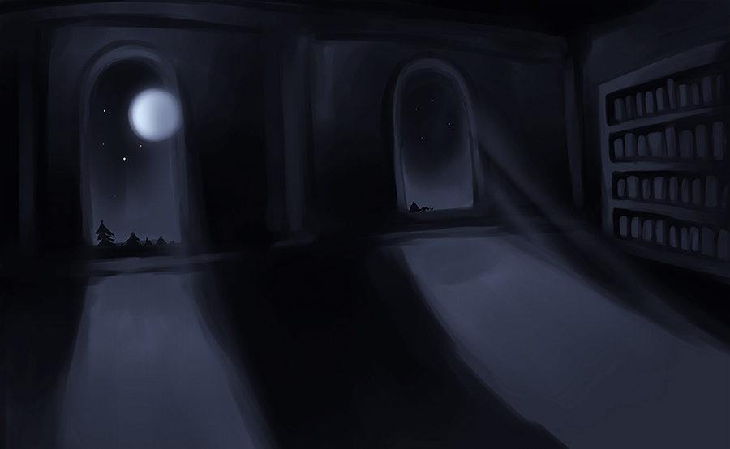

For the exploration sections, which will be in 3D, several environments will be required.
1. The Library
2. A Hallway
3. Two (2) Classrooms
4. The Music Room

For these environments, several models will be required.
1. Bookcase
2. Desk
3. Chair
4. Door
5. Instruments
6. Candle
7. Chalkboard

Animated Flame Cursor:


